KOREA BUILD 2020
Feb 26^{th -} Mar 1st, 2020 KINTEX, Korea

Form 2 REGISTRATION & CONSTRUCTION FORM
- Entries marked with *must be filled.

※EXHIBITOR DETAILS
* Company Name |  |  | * Country
* Address
 |  | * City |  | * Post Code
* Representative
* Tel |  | * Email
* Homepage

※Contact Person
* Name |  | * Job title
* Phone |  | * Mobile
* E-mail

※ Registration & Booth construction (VAT 10% included)
Classification |  | Booths Required | Unit Price | Participation Fee | Remark
□ | Registration Fee | Company | US $ 220 / Company | US $ | Compulsory
□ | Standard Booth Construction | Booth(s) | US $ 550 / Booth | US $ | 1 Booth  (3m x 3m= 9sqm)
□ | Upgraded Booth Construction | Booth(s) | US $ 990 / Booth | US $
□ | Visa Assistant | Company | US $ 55 / Company | US $ | Max. 2ppl

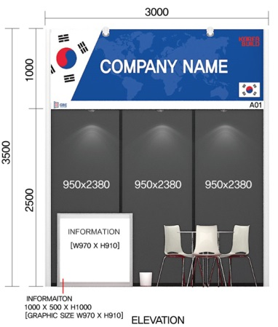
※ Standard Booth Details

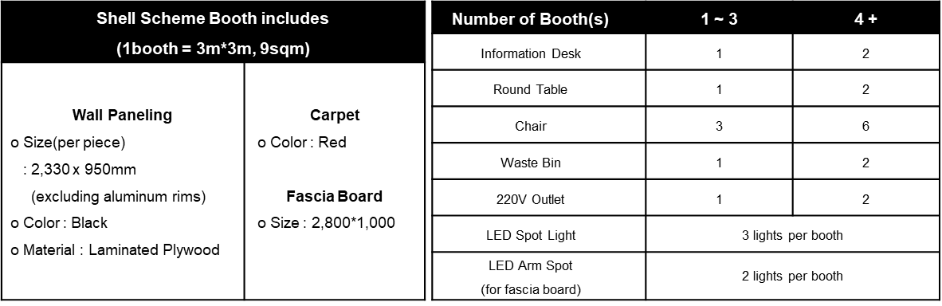

* Bank Detail
- Beneficiary : Global Business Exhibitions
- Bank : IBK(Industrial Bank of Korea) / Mullae JoongAng Branch
- Bank Add : 36, Seonyu-ro 49-gil, Yeongdeungpo-gu, Seoul, Republic of Korea
- Account No. : 141-069032-56-00012
- Swift Code : IBKOKRSEXXX

* Remark: exhibitors should bear wire transfer fee for sending, net full payment as same as invoice MUST be received.

We hereby apply for participation in KOREA BUILD 2020

*Date : *Authorized Signature :
Terms and Conditions for Exhibiting

TERMS OF REFERENCE
In these terms and conditions for exhibiting, the term "Exhibitor" shall include all employees, partnership, firm or individual to whom space has been allocated for the purpose of exhibiting. The term "Organizer" shall mean, “MESSE ESANG” and “Int’l Sales and Marketing Secretariat” shall Global Business Exhibitions(GBE).” including “KOREA BUILD 2020". The term "Exhibition" shall mean “KOREA BUILD 2020”.

ALLOCATION OF EXHIBIT SPACE
The Organizer and Int’l Sales & Marketing Secretariat shall allocate the space in accordance with the nature of the exhibit or in the manner the Organizer and Int’l Sales & Marketing Secretariat deems fit. The Organizer and Int’l Sales & Marketing Secretariat shall reserve the right to change the space allocated to the Exhibitor at any time prior to the commencement of the build-up of the exhibition should the circumstances require changes. Such changes shall be at the discretion of the Organizer and Int’l Sales & Marketing Secretariat. The Exhibitor shall not claim for compensation as a consequence.

APPLICATION AND PAYMENT PROCEDURES
Applications should be sent to KOREA BUILD 2020 Int’l Sales & Marketing Secretariat t along with a transfer slip (check or copy of a bank). The contract shall be established and be put into an effect upon the Exhibitors payment of 100% of the total participation fee and/or the shell-stand cost. The participation fee should be paid within one week after submitting the application form.

CANCELLATION
Should the Exhibitor decide to cancel participation or reduce the total number of booth once the application and contract has been submitted, the following penalty will be put upon the exhibitor to be paid within 7 days of cancellation to the Int’l Sales & Marketing Secretariat. Participation fees already paid shall be taken for the penalty. Should that amount not be sufficient, the difference must be paid within 7 days and any excess amount shall be returned.
PENALTY RATE:
* Cancellation until 80 days before the show opens : 50% of the total participation fee.
* Cancellation from 30 days to 60 days before the show opens : 80% of the total participation fee.
* Cancellation within 30 days from the show opens : 100% of the total participation fee

INSTALLATION AND REMOVAL
The installation and removal of the exhibits and booths must be completed by the date and time stipulated by the Organizer and Int’l Sales & Marketing Secretariat. Exhibitors shall indemnify the Organizer and Int’l Sales & Marketing Secretariat against any loss, which may be caused by delay or damage to the Exhibition Hall.

COORDINATION OF EXHIBIT WITH ORGANIZER
Exhibitors shall provide descriptions of their exhibits before the construction of the exhibits and ensure that it is in compliance with regulations and restrictions on booth design and activity. Exhibitors shall also agree to provide the Organizer and Int’l Sales & Marketing Secretariat with the necessary information facilitating the overall promotion of the KOREA BUILD 2020.

INSURANCE, SECURITY AND SAFETY
Exhibitors are required to subscribe to all risks in the insurance policy on all equipment and products during the Exhibition as well as during set-up and dismantling. The Organizer and Int’l Sales & Marketing Secretariat shall not be held responsible for any loss, theft, or damage to any articles belonging to the Exhibitor. Materials used in the stand and display construction must properly fireproof in accordance with the local fire and safety regulations. The Organizer and Int’l Sales & Marketing Secretariat shall reserve the right to limit any constructions or demonstrations that pose as potential safety hazards.

USE OF EXHIBIT SPACE
Exhibitors are bound to exhibit the subscribed products and to present the stands with competent personnel during the open hours of the Exhibition. Activities of the Exhibitor shall be confined within limits of the Exhibitor's booth. The exhibit will be consistent with the theme of the Exhibition and the Organizer and Int’l Sales & Marketing Secretariat reserves the right to restrict exhibits, which may cause detraction from the general character of the Exhibition.

RESTRICTION ON SELLING
It is agreed that the sole purpose for contracting exhibit space is to display and / or demonstrate equipment, supplies and/or services. Cash sales within the confines of the exhibit space are prohibited.

LIABILITY
It is mutually agreed that the Organizer and Int’l Sales & Marketing Secretariat shall not be liable to the Exhibitors for any damages made to and/or loss of the Exhibitor's property, or for injuries to persons under any circumstances.

BREACH OF THE CONTRACT AND WITHDRAWALS BY EXHIBITOR
In the event that the Exhibitor refuses to use all or part of the spare allocated or the Exhibitor defaults on the payment, the Organizer and Int’l Sales & Marketing Secretariat shall reserve the right to terminate the contract forthwith. In addition, the stand charges shall not be refunded. If the Exhibitor withdraws from participation without the Organizer and Int’l Sales & Marketing Secretariat 's approval, the payment made by the Exhibitor shall not be refunded.

CHANGES
The Organizer reserves the right to change the venue and duration of the Exhibition under any exceptional circumstances. In the event of a change of venue and/or date, or cancellation of the Exhibition, the Exhibitor shall not be entitled to any claim for compensation in connection with the booking for participation.

SUPPLEMENTARY
When necessary, the Organizer and Int’l Sales & Marketing Secretariat shall have the right to issue supplementary regulations in addition to those in the TERMS AND CONDITIONS FOR EXHIBITING. Those regulations and instructions shall be binding on the Exhibitors. The Exhibitor shall observe the KINTEX Rules and Regulations.

ARBITRATION OF DISPUTES
Any disputes, differences or questions arising hereafter between the Organizer and the Exhibitor concerning the true construction of these TERMS AND CONDITIONS FOR EXHIBITING or the rights and liabilities of the parties thereto shall be settled in accordance with the Commercial Arbitration Rules of the Korean Commercial Arbitration Board. The verdict of the above arbitration shall be final and binding upon both parties.

We agree with above terms & conditions.

*Date : *Authorized Signature :

